|  |  |
| --- | --- |
| **[Project] – External Document** |  |
| COMP6681001  Web Programming |
| Odd Semester Year 2022/2023 |

* Project Title

MaiBoutique

* Introduction

**MaiBoutique** is a website for shopping clothes easily with many options available. **MaiBoutique** provides a wide selection of clothes that are suitable for use wherever you go. The number of online stores now may make you confused about which e-commerce shop to buy from, but **MaiBoutique** is here to help you choose the best clothes and at a price that fits in the pockets of many people.

* Report / Documentation

1. Run ***composer install***
2. Copy .env.example and change file name into .env
3. Change DB_DATABASE to your preferable DB or you can create DB with the name of maiboutique
4. Before run the server, please run ***php artisan migrate:fresh --seed***
5. Run ***php artisan storage:link***
6. Here is credential for login:
   * Admin:

Email: [admin@gmail.com](mailto:admin@gmail.com)

Password: password

* + Member:

Email: [user@gmail.com](mailto:user@gmail.com)

Password: password

Link Github: <https://github.com/alexgrant20/maiboutique-lab.git>

1. Welcome Homepage

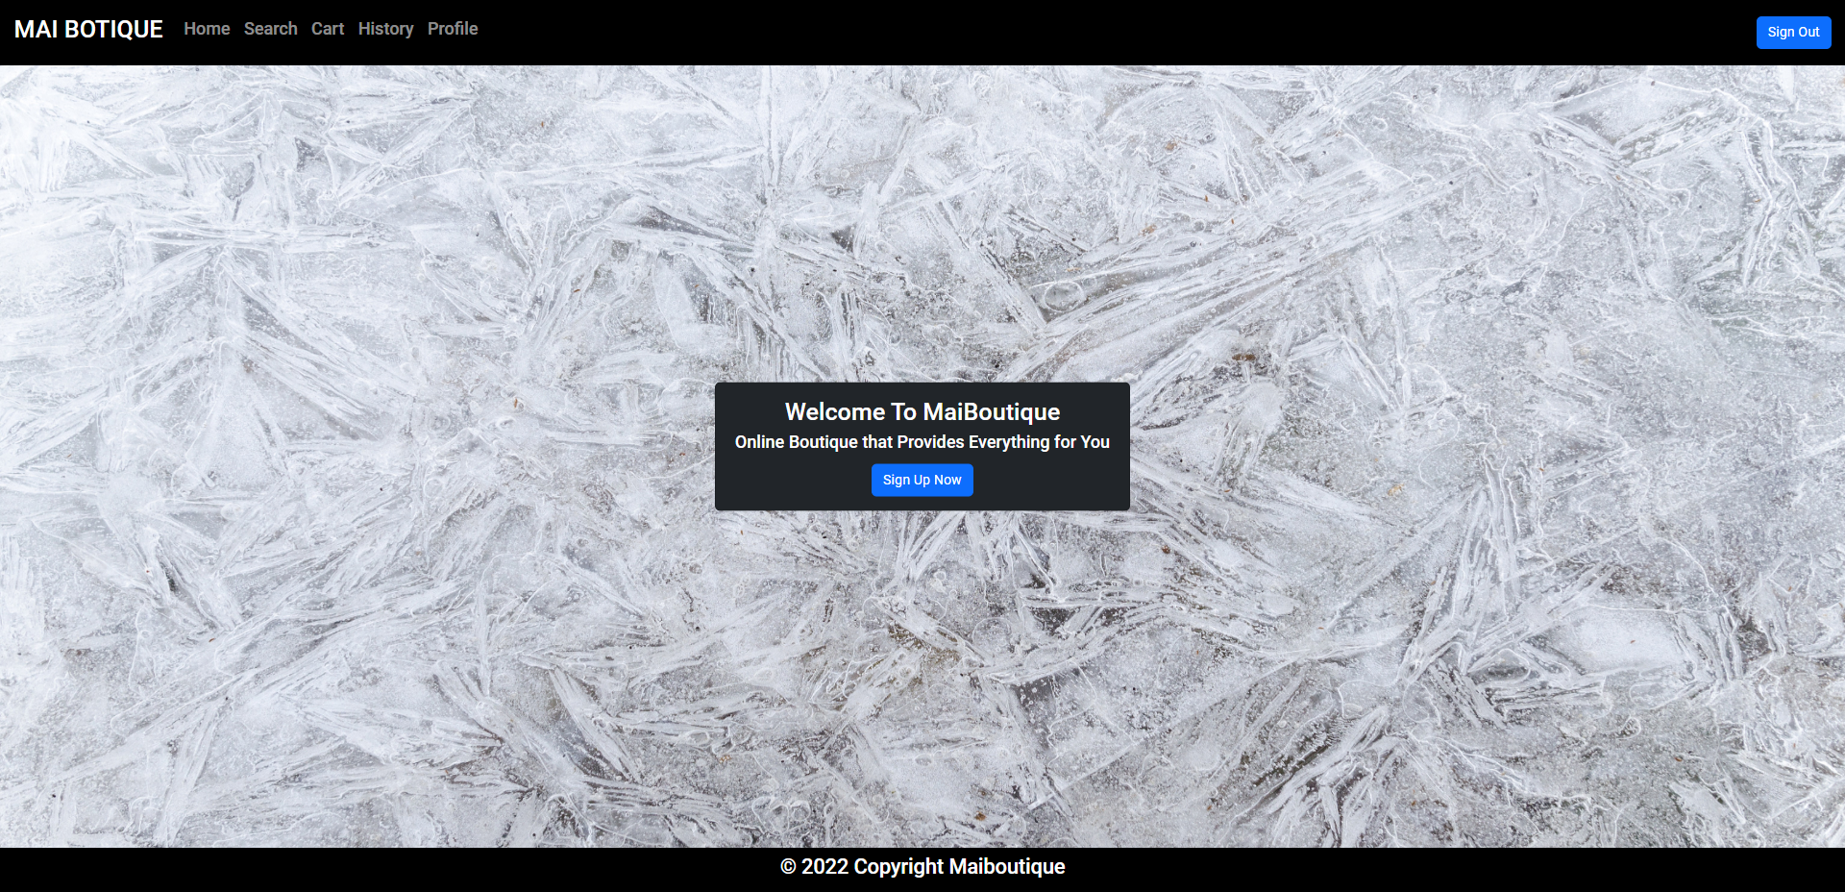

**Figure 1. Welcome Page**

1. Sign In

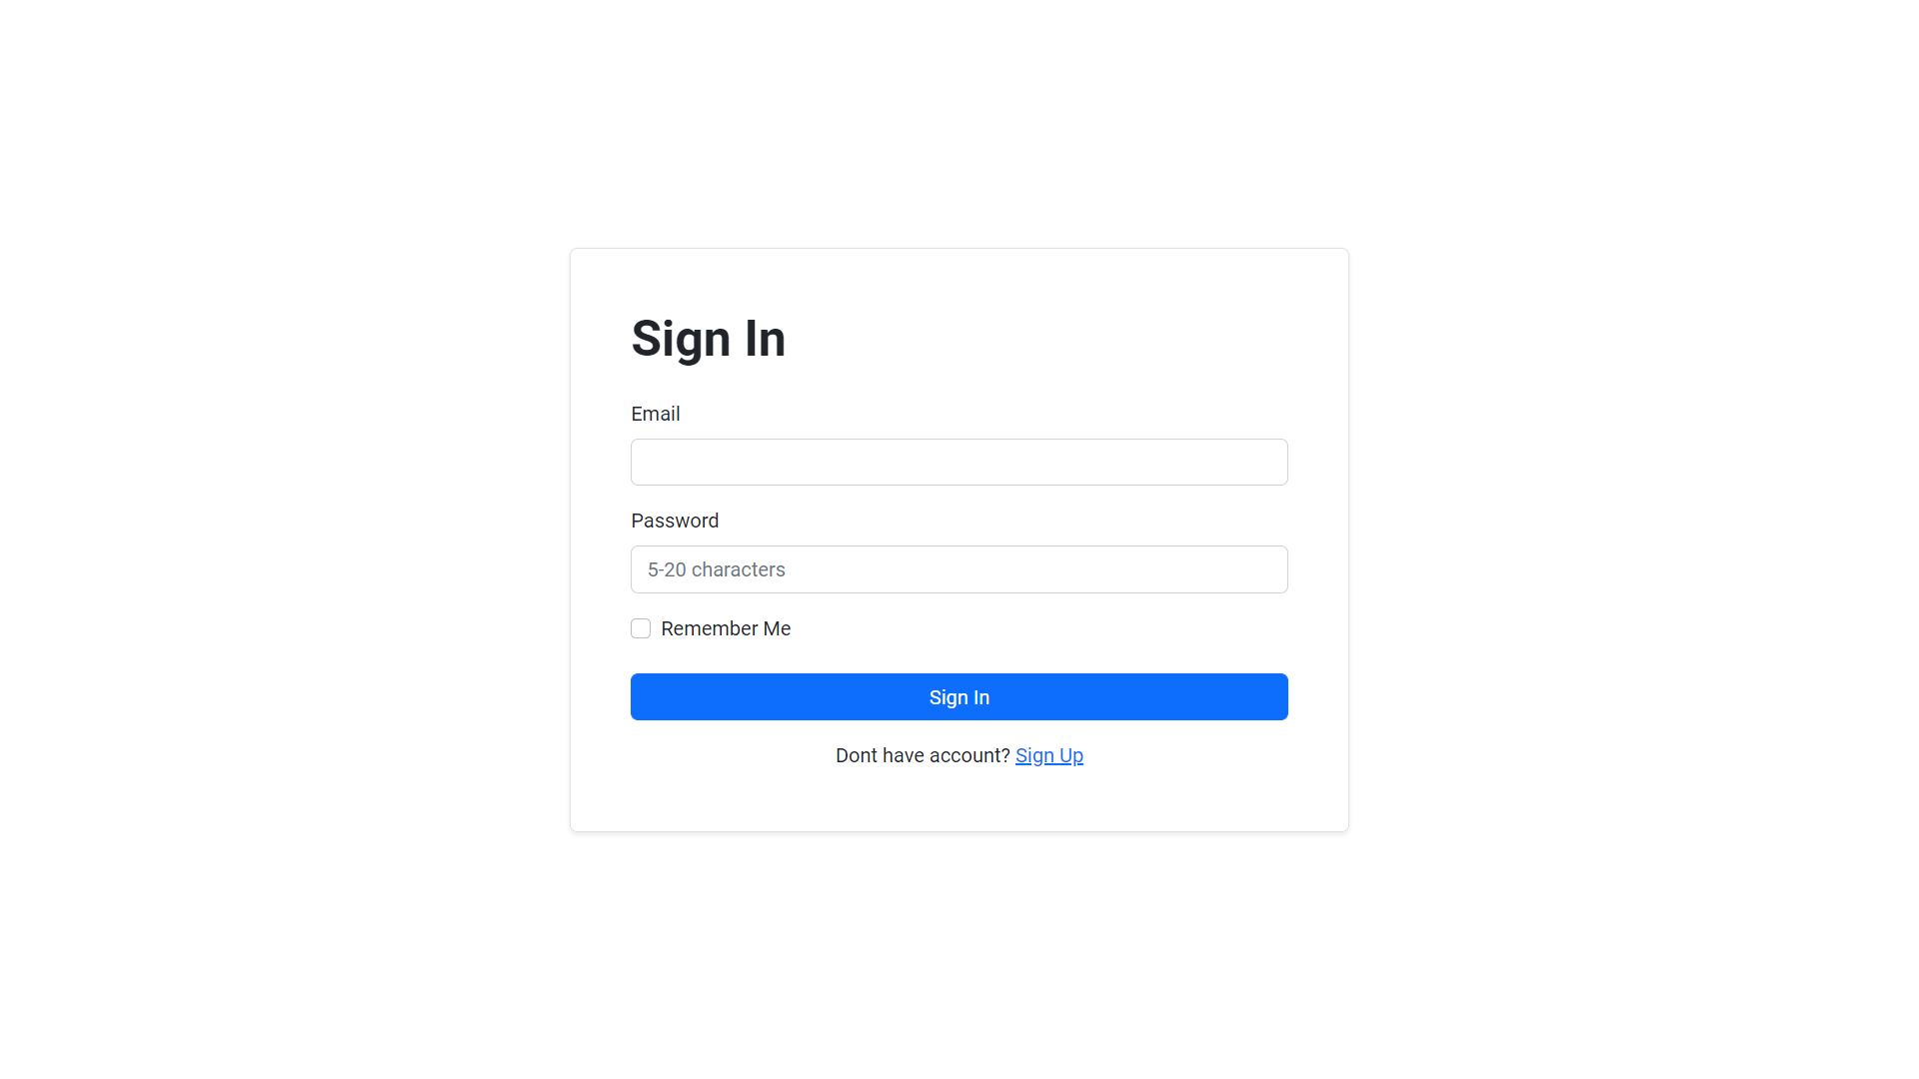

**Figure 2. Sign In Page**

1. Sign Up

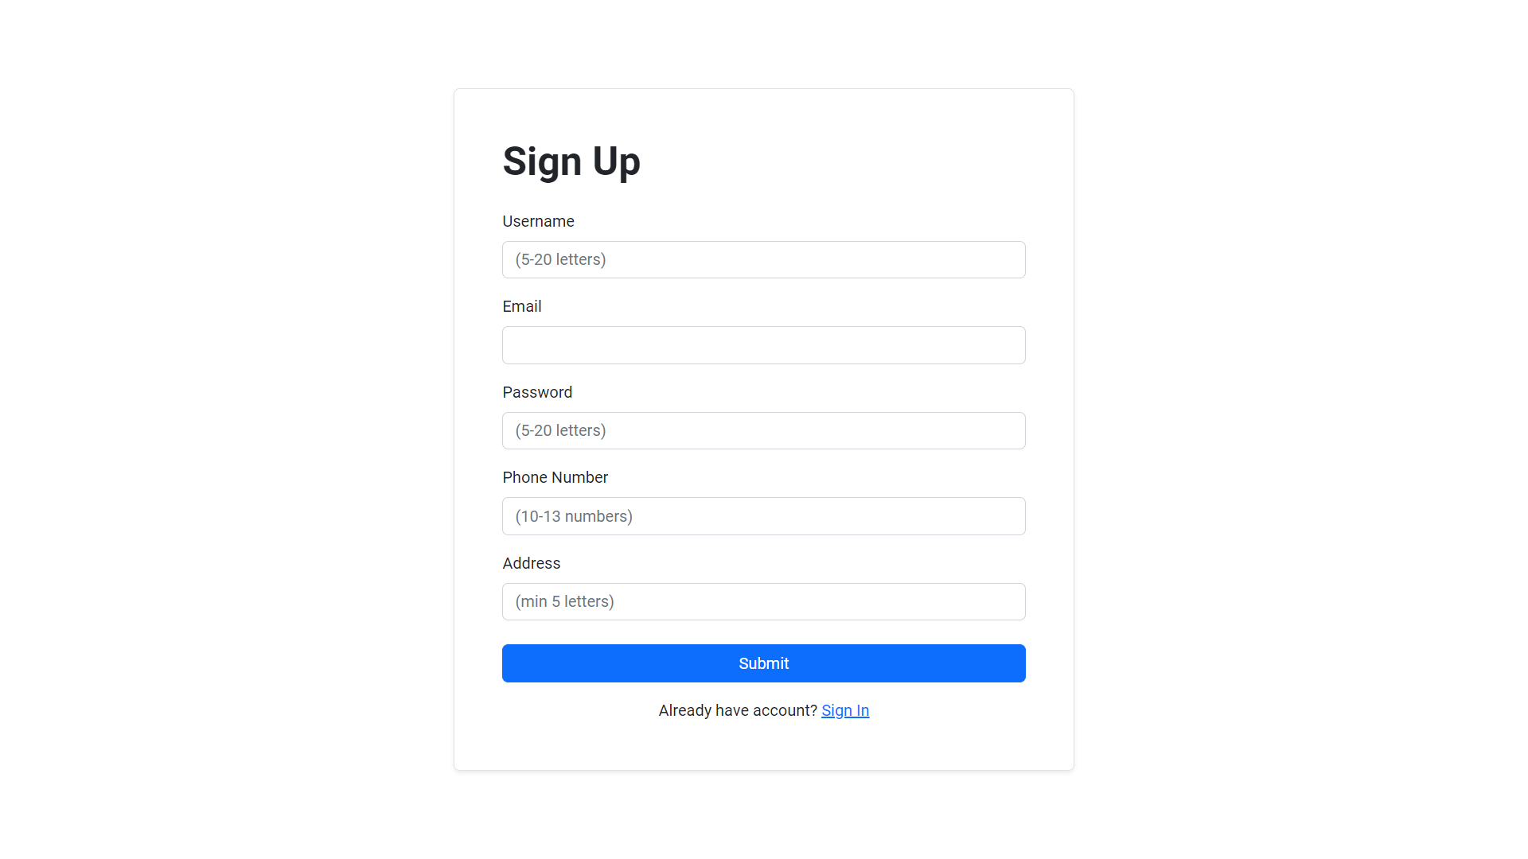

**Figure 3. Sign Up Page**

1. Home

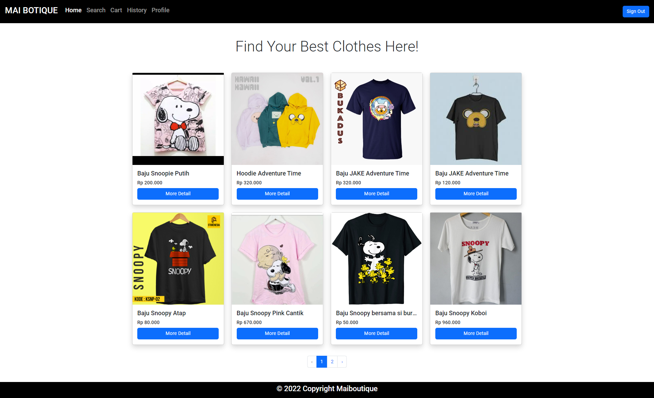

**Figure 4. Home Page with menu (for member)**

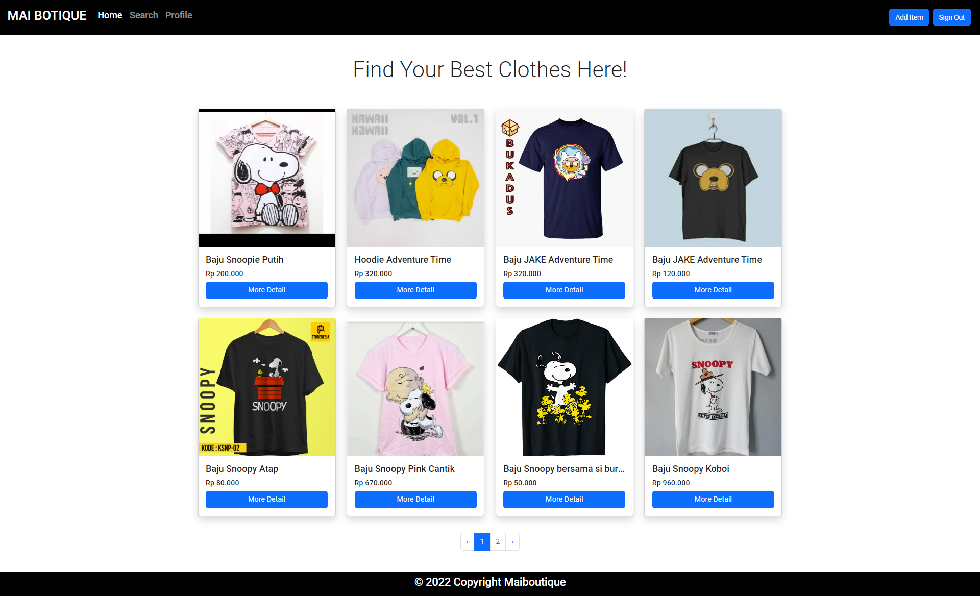

**Figure 5. Home Page with menu (for admin)**

1. Detail Product

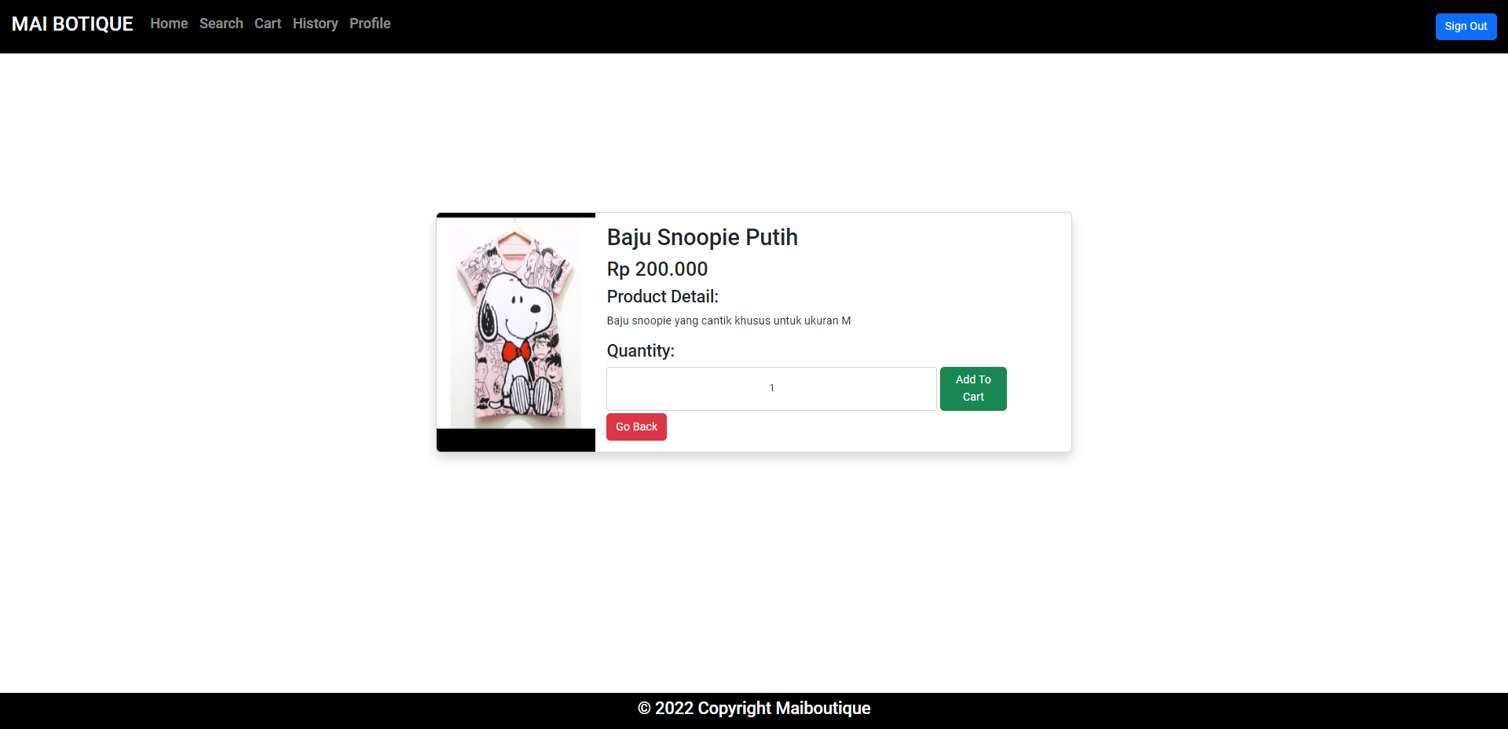

**Figure 6. Detail Product Page (for member)**

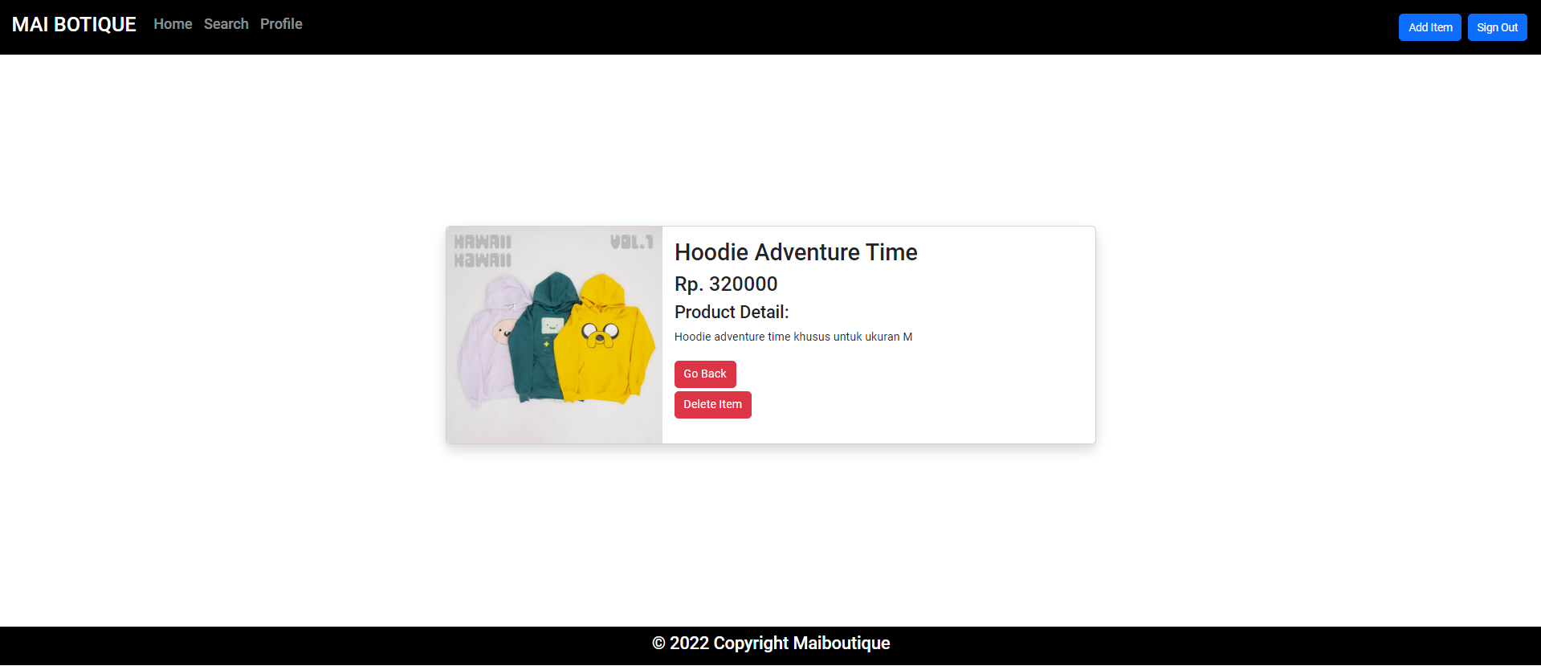

**Figure 7. Detail Product Page (for admin)**

1. View Cart

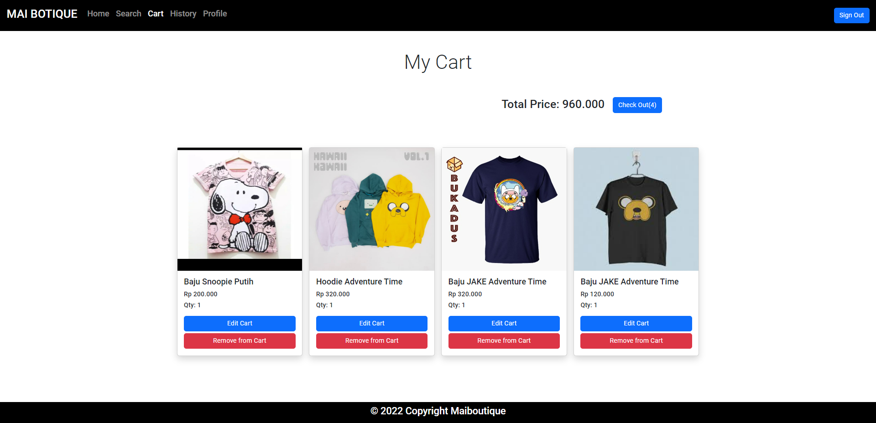

**Figure 8. Cart Page**

1. Edit Cart Page

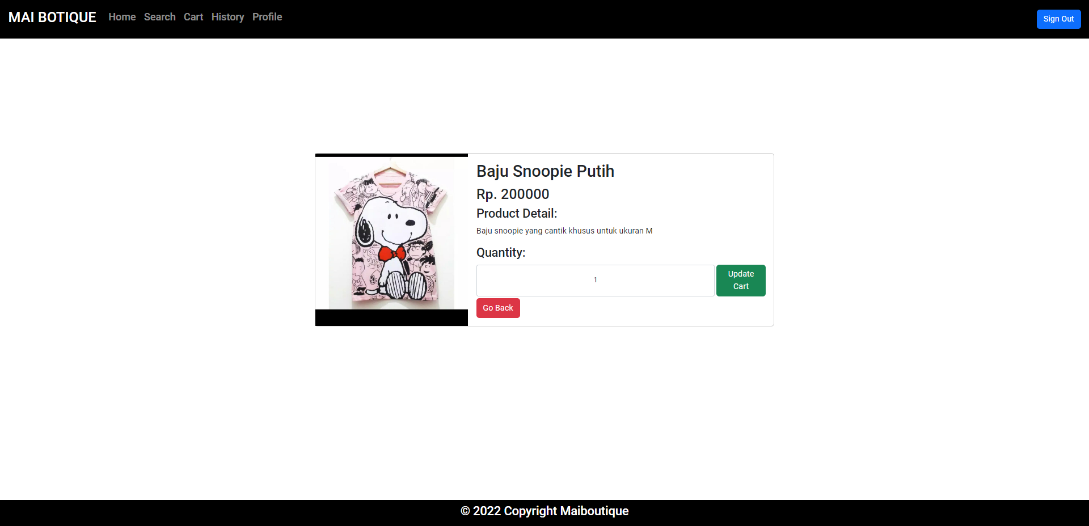

**Figure 9. Edit Cart Page**

1. Transaction History

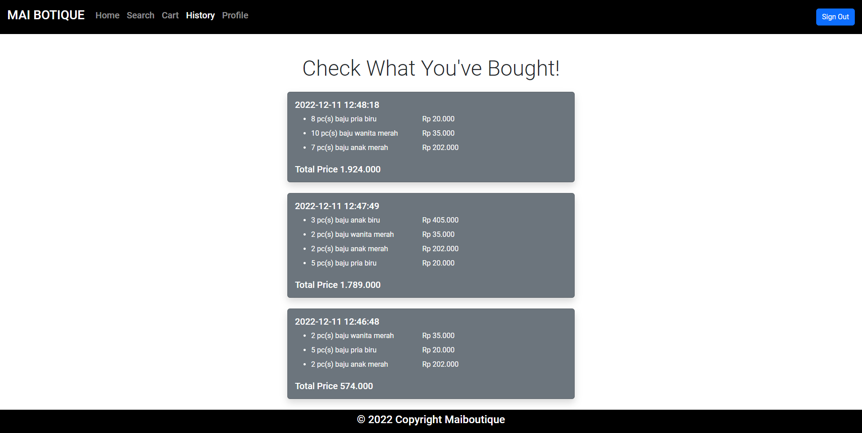

**Figure 10. Transaction History Page**

1. View Profile

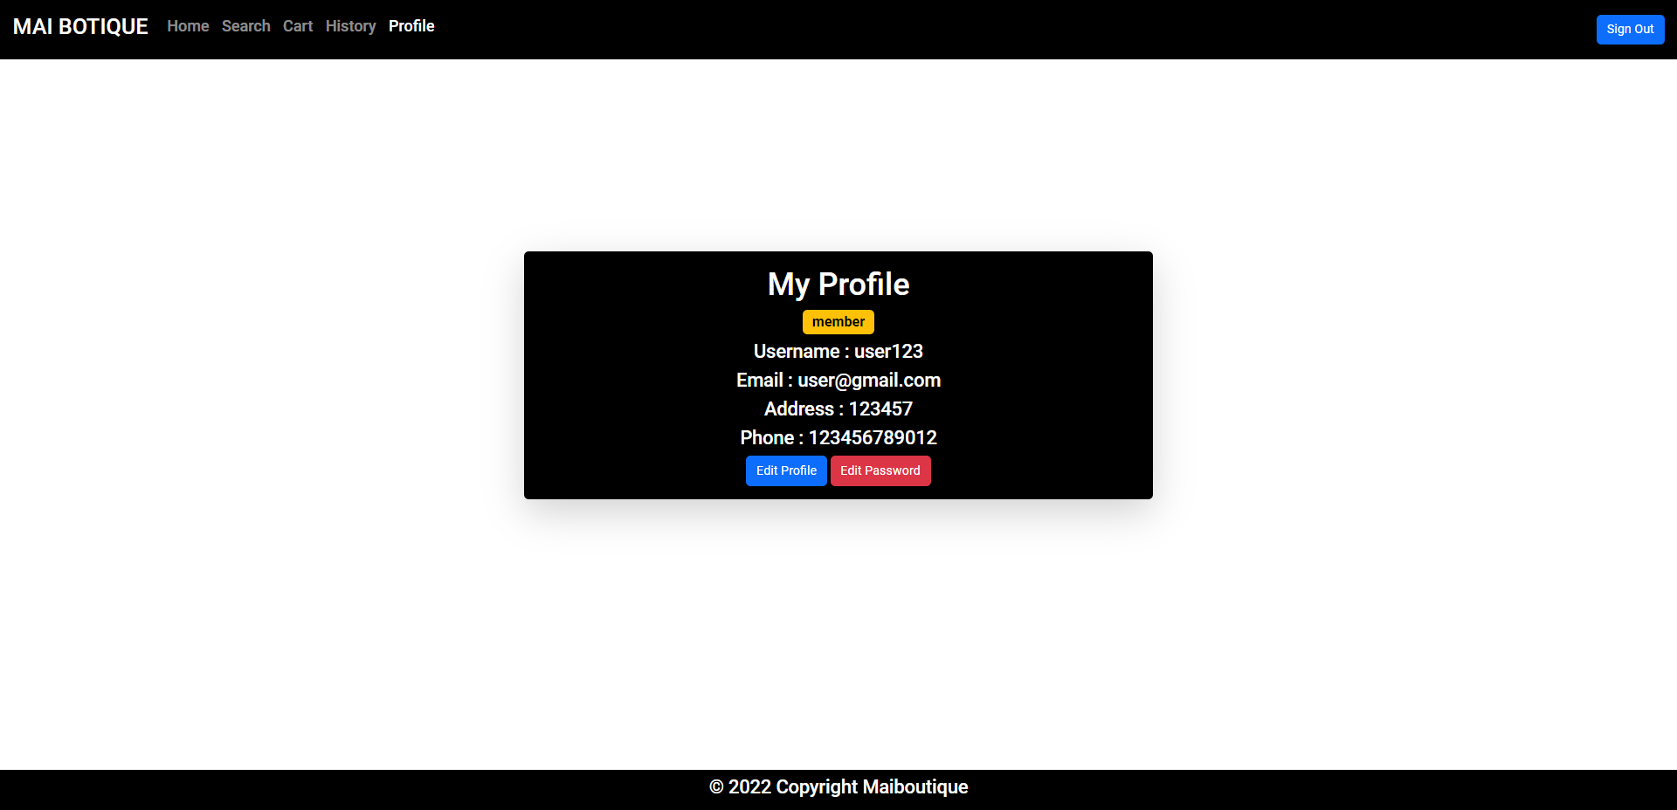

**Figure 11. View Profile (for member)**

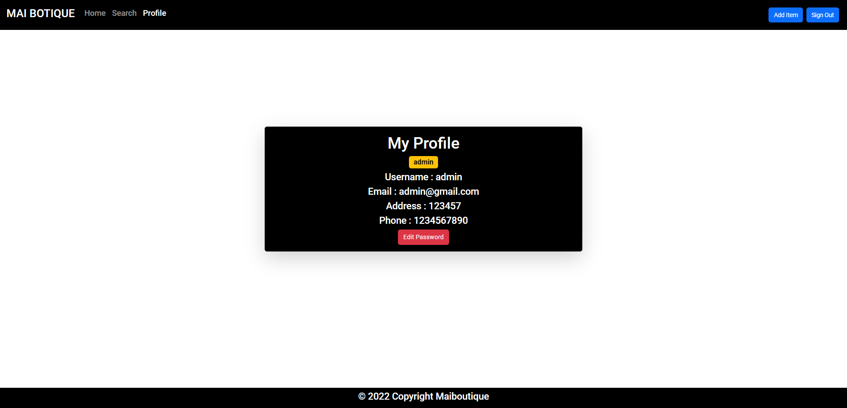

**Figure 12. View Profile (for admin)**

1. Edit Profile

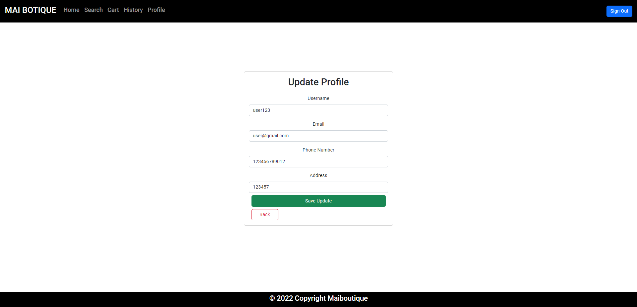

**Figure 13. Edit Profile**

1. Edit Password

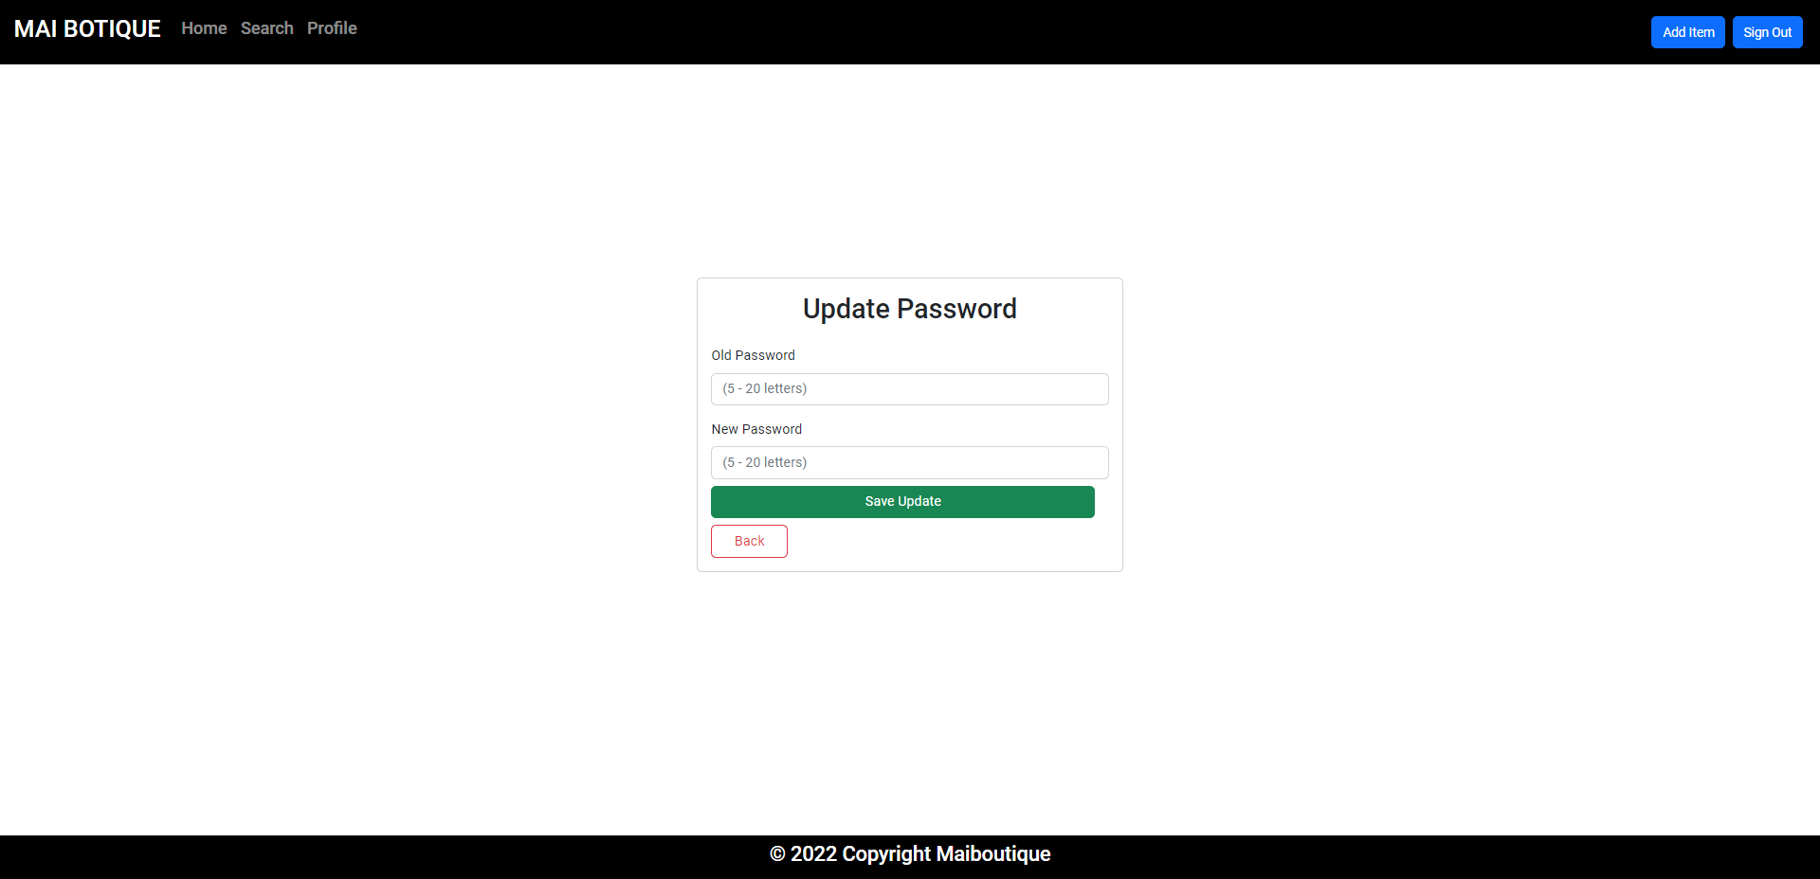

**Figure 14. Edit Password**

1. Add Item

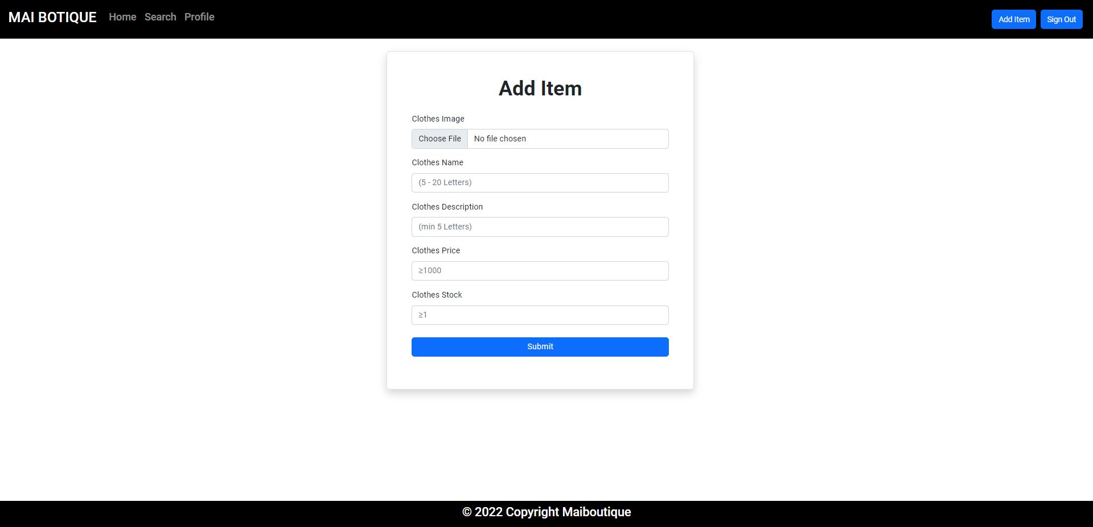

**Figure 15. Add Item Page**

1. Search Page

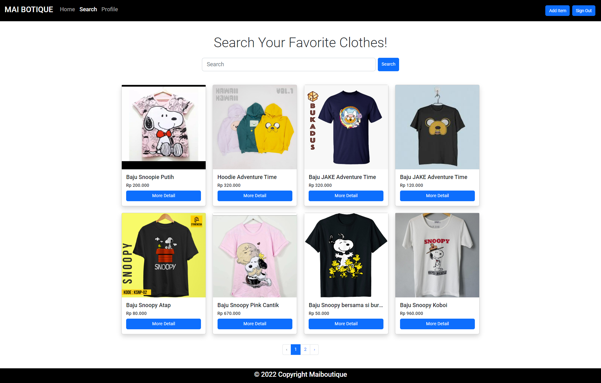

**Figure 16. Search Page**

* Reference



* Background For Welcome Page

Source: canva.com

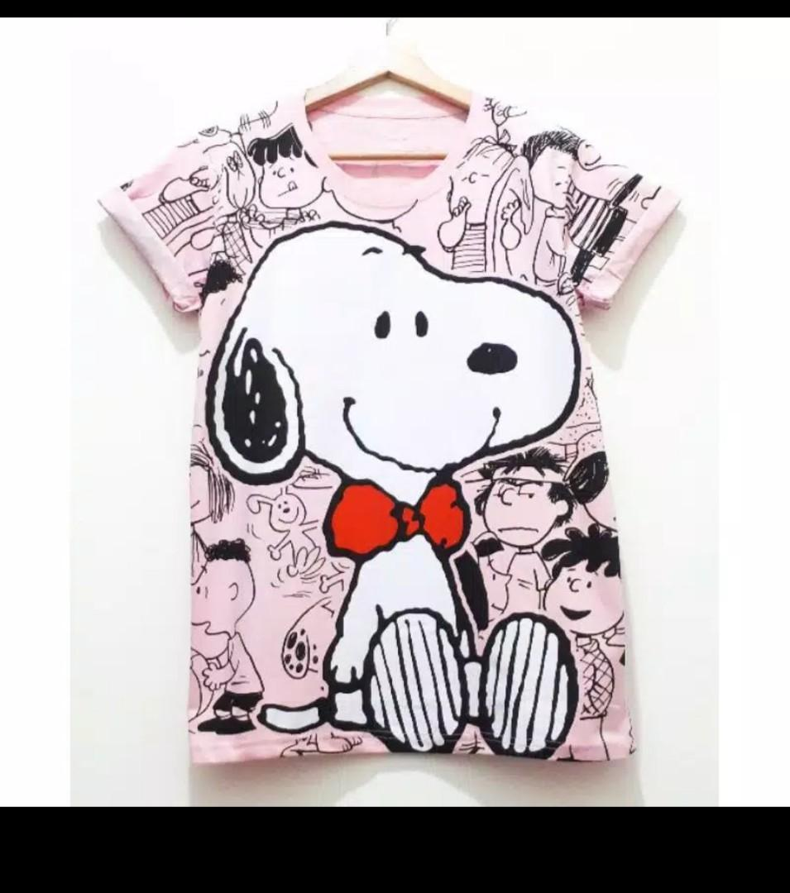

* Product 1

<https://media.karousell.com/media/photos/products/2020/10/9/kaos_snoopy_jumbo__baju_snoopy_1602221944_c7567209_progressive.jpg>

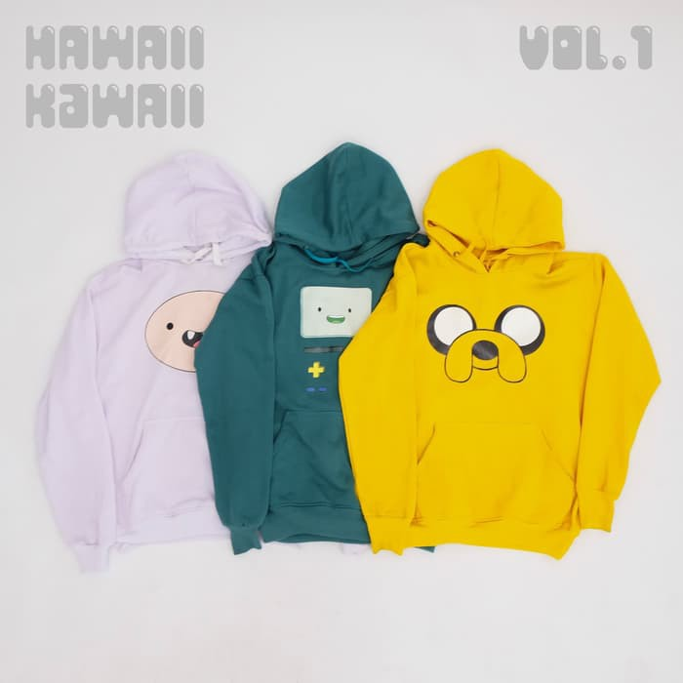

* Product 2

<https://cf.shopee.co.id/file/597ea2c1e3be9ff96bfe6fd83831ca49>

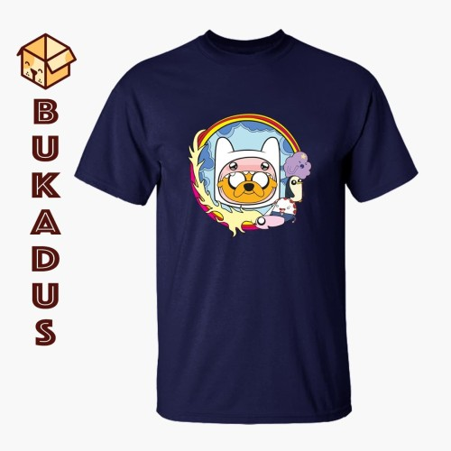

* Product 3

<https://images.tokopedia.net/img/cache/500-square/product-1/2019/12/10/4251424/4251424_835545f5-2cfd-430e-944c-dd1db2755a78_1200_1200>

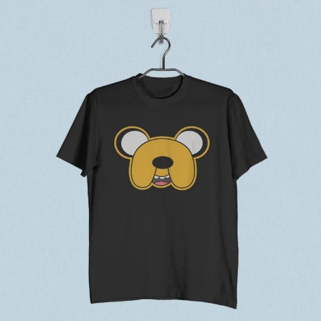

* Product 4

<https://cf.shopee.co.id/file/22a25e11a0eb8149796470f71d101ec0>

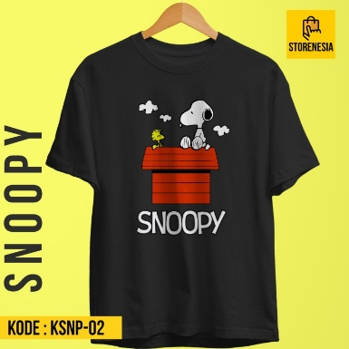

* Product 5

<https://images.tokopedia.net/img/cache/700/VqbcmM/2021/7/12/f603b4db-81a5-4eb7-b3b7-a5c65bdc2c37.jpg>

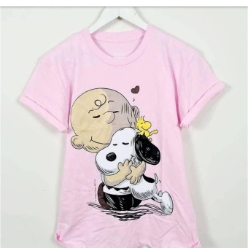

* Product 6

<https://media.karousell.com/media/photos/products/2021/6/10/kaos_snoopy__baju_snoopy__kaos_1623316008_3f43d03f_progressive.jpg>

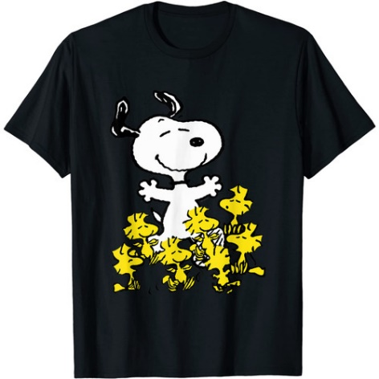

* Product 7

<https://images.tokopedia.net/img/cache/500-square/VqbcmM/2021/11/19/2ac559c7-db8f-4940-bdb0-8c4dbf5f7169.jpg>

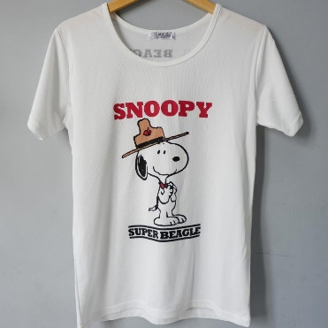

* Product 8

<https://media.karousell.com/media/photos/products/2021/9/6/snoopy_peanuts_kaos_baju_tshir_1630941441_7e91e303_progressive>



* Product 9

<https://id-live-01.slatic.net/p/1610dba0fe4a04217e067fa9edc5268f.jpg>

* Group Member
* 2401960422 – Steven Alexander Grant
* 2440007762 – Francesco Jovan